**Collaborative Traffic Control Module Using Inductive Loop And Video Surveillance**

Anshuman Maharana, Suvam Mishra, Pruthi Pritam Mahala

NIT Rourkela

***Abstract: Collaborative traffic control, is a modern attempt at an efficient management of traffic using inductive loop sensors that can detect vehicles under a heterogeneous and less-lanedisciplined trafﬁc and thus can be used to support a trafﬁc control management system in optimizing the best use of existing roads. The loop sensor proposed in this paper detects large (e.g., bus) as well as small (e.g., bicycle) vehicles occupying any available space in the roadway, which is the main requirement for sensing heterogeneous and lane-less trafﬁc. To accomplish the sensing of large as well as small vehicles, a multiple loop system with a new inductive loop sensor structure is proposed. The proposed sensor structure not only senses and segregates the vehicle type as bicycle,motorcycle,scooter,car,andbusbutalsoenablesaccurate counting of the number of vehicles even in a mixed trafﬁc ﬂow condition. A prototype of the multiple loop sensing system has been developed and tested. Field tests indicate that the prototype successfully detected all types of vehicles and counted, correctly, the number of each type of vehicles. Thus, the suitability of the proposedsensorsystemforanytypeoftrafﬁchasbeenestablished. Index Terms—Inductive loop, intelligent transportation, multiple sensors, vehicle detector, virtual instrument.***

I. INTRODUCTION

ACCURATE and real time measurement of trafﬁc parameters such as type and number of vehicles, their individual speeds and overall ﬂow pattern are essential to successfully implement an Intelligent Transportation System (ITS) and thus enable optimal utility of existing roadways. For the accurate measurement of such trafﬁc parameters, an efﬁcient vehicle detector is essential. The sensors output should be such that the type, speed, and occupancy time of each vehicle can be determined. The trafﬁc ﬂow sensors can be broadly classiﬁed into intrusive and nonintrusive types based on whether they need to be placed below the road surface or not. The nonintrusive methods are based on video image processing, microwave radar, ultrasonic, optical, and laser radar, which can be installed above the roadways [1]. Based on the sensing principle used, the existing intrusive trafﬁc ﬂow sensors can be classiﬁed as inductive loop, magnetometer, and pressure switch types [1]. These sensors are either embedded underneath the top surface of the roadway or placed on the surface of the road.

Manuscript received June 20, 2011; revised August 28, 2011; accepted August29,2011.DateofpublicationDecember6,2011;dateofcurrentversion April 6, 2012. This work was supported by the Ministry of Urban Development underProjectNo.K-14011/28/2007-UT.TheAssociateEditorcoordinatingthe review process for this paper was Dr. Subhas Mukhopadhyay. The authors are with the Indian Institute of Technology (IIT) Madras, Chennai, India (e-mail: boby@ee.iitm.ac.in). Color versions of one or more of the ﬁgures in this paper are available online at http://ieeexplore.ieee.org. Digital Object Identiﬁer 10.1109/TIM.2011.2175037

Fig. 1. Illustration of an inductive loop-based vehicle detection scheme at a junction.

Among the trafﬁc ﬂow sensors mentioned above, the inductive loop detectors [2]–[7] are widely used as they provide goodsensitivitycoupledwithacosteffectivesolution.Research papers discussing improvement of loop detectors for better speed measurement [8], [9] and classiﬁcation [10]–[16] for lane-disciplined trafﬁc conditions were reported. However, the existing inductive loop detectors are mainly suitable for vehicular trafﬁc that conforms to lane discipline, and these sensors will not properly function when there are parallel movement of vehicles, as shown in Fig. 1, within the same lane (same loop area), e.g., roads with vehicles occupying any available road area without restricting to lanes, and heterogeneous trafﬁc with vehicles of widely varying characteristics (from nonmotorized vehicles such as bicycles and animal-drawn vehicles to trucks and tractor trailers) occupying the same road space. More than that, a loop designed to detect large vehicles (e.g., bus) cannot detect a small vehicle such as bicycle, reliably. Thus, the existing loop detectors are suitable only for the lane-disciplined and homogeneous trafﬁc conditions. The trafﬁc conditions in many countries do not conform to an orderly lane system. In such situations, vehicles occupy any available road area without adhering to a lane system. Thus, there is a need to develop detectors that can sense the type of vehicle (bus, car, motor cycle, and bicycle) under heterogeneous and lane-less trafﬁc conditions.

***APPROACH***

A previously developed ATC(Automated Traffic Control) Module was able to detect static traffic through IP camera and assign red light, offset time and green light time based on the ratio of density of the corresponding lanes. In Collaborative Traffic Control Module we attempt to upgrade the existing module by detecting the traffic inflow which is not detected by the camera. Hence the system becomes more dynamic and the overall efficiency is increased.

We attempt to do so by using multiple inductive loops buried under the lanes. Inductive loops detects the presence of metals due to the increase in inductance and hence peaks obtained at the resonant frequency

1. **Raspberry PI**

Raspberry Pi 3 board: 802.11n WiFi, Bluetooth 4.0, and a quad-core 64-bit ARM Cortex A53 running at 1.2 GHz. The other accessories to program and run Raspberry Pi.

.

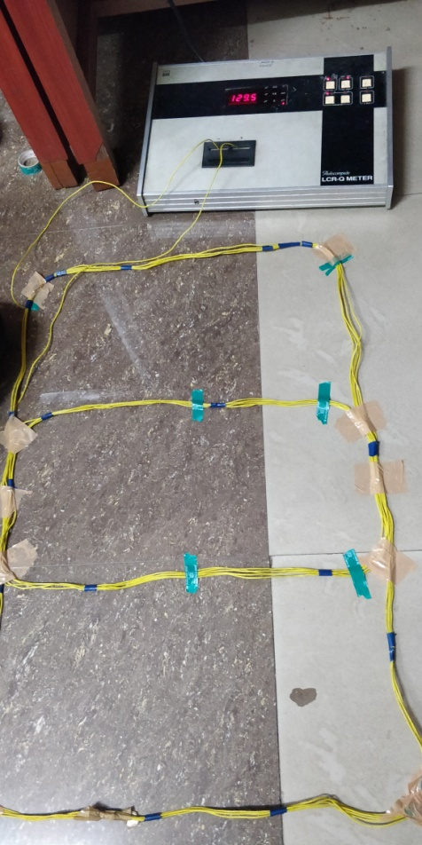 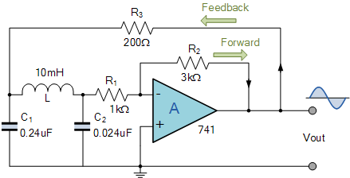

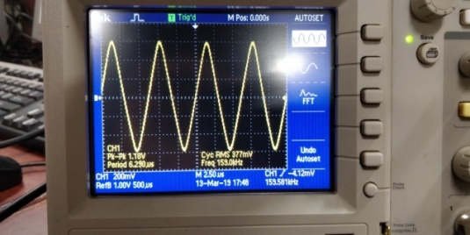 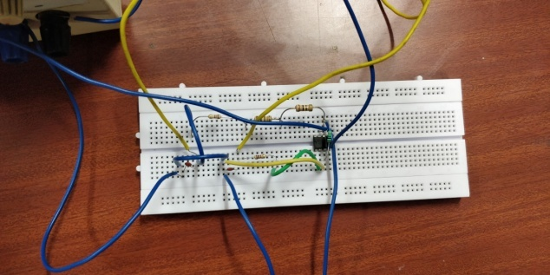

II. Components Required

1. IC 741 OP-AMP
2. MCP3008 10-bit ADC
3. 860mm x 530mm Inductive Loop Sensor
4. 2x 0.01uF Capacitors
5. Resistors(200, 1k, 1M ohms)

III. Progress

* Got a basic idea about functionality of Raspberry Pi and its compatibility for this project.
* Interfaced the Raspberry Pi with a 10-bit ADC (MCP3008).
* Python code was written to find the sampling rate of the data incoming from the sensor to verify the ability of the microcontroller.
* Constructed the Colpitt’s oscillator and observed the change in output voltage and frequency upon passing a sheet of metal over it.

VI. Future Work Plan

* Interface the sensor via ADC to the microcontroller and collect data.
* Analyze the data and record the real time values in excel sheet.
* Implement the given sensor in a working environment and assigning voltage modulation ranges produced by various vehicles and assign corresponding weightages.
* Installing Multiple Inductive Loops along the width of the road using a switching circuit to eliminate mutual inductances between them.
* Collect various datasets of corresponding vehicle types for detection.